

Assignment 1 Data Visualization



February 23, 2023

Dale Randall

Contents

**First Task** 2

Policies and Procedures 2

**Second task** 3

**Excel** 3

**Third Task** 4

**Tableau** 4

**First Task**

Policies and Procedures

There are a few key policies that need to be followed while working with data.   
1. Data Security: Data security is of utmost importance when dealing with data, as it ensures the safety and integrity of the data. It should be ensured that all data is encrypted, kept secure on secure servers, and all access to the servers is limited and monitored.   
  
2. Data Privacy: Any data gathered must comply with relevant privacy laws and regulations and should only be accessed, used, and shared with the user’s consent. It is important to ensure that any sensitive information is kept secure and only shared with those with authorised access.  
  
3. Accurate data: Accurate data is essential for a successful analysis, and so it is important to properly validate and verify the data you are using. Accurate data helps to ensure that your analytics are reliable and that your predictions are accurate.  
  
4. Data Accessibility: Data must be accessible and easy to collect, store, and use if you are to use it in your analysis. It is important to ensure that data is collected in a uniform format to make retrieving it easier.  
  
5. Responsible and Ethical Use: Data should be used only for the intended purpose and must not be abused or misused in any way. It is important to respect the rights of individuals and to not invade privacy in any way.  
  
As a data analyst, it is important to be aware of these rules to maintain data security and privacy, as well as ensure accurate and reliable analytical results. Not adhering to these policies can lead to costly mistakes, data breaches, and other potential risks. Following these policies will help protect sensitive data as well as help ensure accurate analytics and predictions

**Second task**

**Excel**

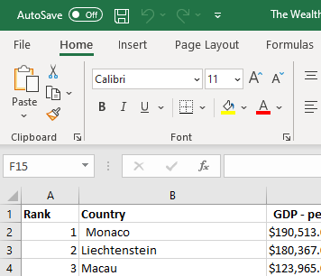After opening the data in Excel, I will start by setting a password on my sheet this can be done by clicking **File** at the top left corner then click on the box named **Info**

One you have done this you will see a box with a lock named (**Protect Workbook).** Click the drop down and select **Encrypt with password.**A box will pop up (Shown as below) for you to create and input a password and press **OK,** it will then ask you to input the password again to confirm. Once done press **OK**

Once you have pressed **OK** you will seethe box you previously clicked now says  
(A password is required to open this workbook). click the box at the top left named **Home** to go back to the worksheet

We are going to change the data in column C from $ to £ so highlight column C, this can be done by clicking **C** then in the toolbar to the top click the dropdown box on custom. At the bottom of the drop down clicked the box names **More number formats.**A box will pop up (Shown to the right here)you will want to click Currency in the Catalogue box  
and click the drop down next to Symbol (The drop-down box maybe names none) click the **£** and press ok

Now we will Turn the GDP sheet into a table so highlight all rows and Columns and click **Insert** at the top next to home. Click the box called **Table** in the tab.  
  
One this as been done a box seen on the right will pop up, make sure it has a small tick for (My table has headers) and click **OK**

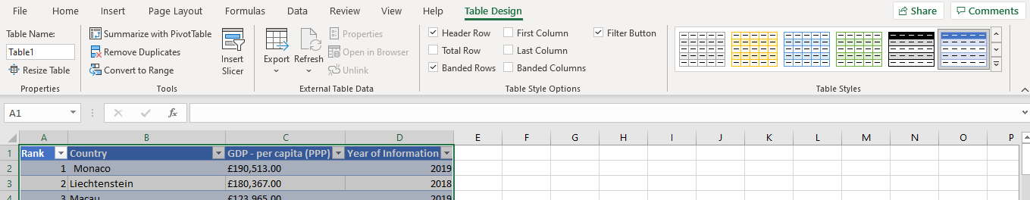One you clicked **OK** the data you highlighted before will be highlighted blue your showed as below   
you can change the colour of this table by selecting any of the colours on the top right also showed in the screenshot below

Now we will filter the table to display only the information for 2019 so in the header of the table named **Year of information** click the dropdown button in cell **D1** You can either search for 2019 or you can untick select all and just tick 2019 and click ok

Once you have clicked ok you table will show all data for the Year of information as 2019

Next, we will create a chart that will only display the following data ‘Rank, Country and GDP - per capita (PPP).   
so, highlight all your data in columns. **(A, B & C)** once this has been done select **insert** next to home at the top left, I will select the box in the tool bar called **Recommended Charts**

The system in Excel will automatically recommend what kind of chart is suitable for the data in the table I have selected

If you are happy with the charts shown select one and press OK,   
  
The chart you have selected will appear next you your table.  
  
  
(See screenshot below)

If you are happy with your chart, make sure to add a visible title and edit X and Y axis labels

(Shown here in the green circles)

Next, we will move out chart to a new sheet   
click the small plus next to sheet called (Smartphones) and a new blank sheet will appear

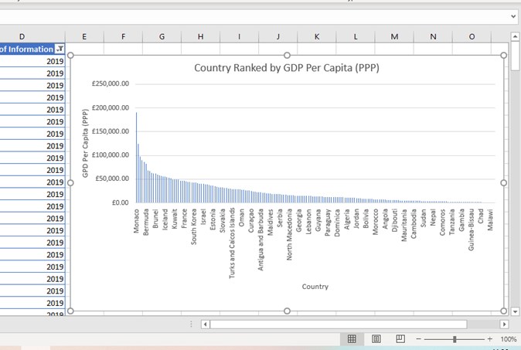Go back to the sheet called GDP and click the chart right click the chart and copy

Once this step had been done head back to the new sheet called (Sheet1), right click on any cell and click paste. The chart will now appear on thew new sheet.

To rename the new sheet right click on the sheet name (Sheet1) click on the box **Rename**, name the new sheet (Visual Date)

Next, we will create a sort for the top 20 highest ranking counties in the sheet named GDP.

In column **B1** click the dropdown box go down to Number filter another box will appear  
(Shown to the right hear)  
go across to top 10 and click left   
  
a small box will pop up shown as below  
as we went to show the top 20 change the 10 to a 20 and make sure it says top and press the ok button

Now we have out top 20 we are going to create a new Bar chart to display them.

So, in our chart we want to show Country and the GDP per capita so we will high light both columns seen to the right, once highlighted go to **Insert** at the top left next to Home and again like the last chart we made. We will lick **Recommended chart**

Once you have found the chart that suits you click OK, your new chart will appear on your work sheet **(GDP).** Click the chart and move it below your Top 20 table

(See screenshot to the right)

Now lets Colour the background of the chart start by highlighting the cellfrom A230 down to D244 one they highlighted Select the paint on the screenshot to the right add a fill colour icon and sellect a colour

Next we will create 3 macro buttons, print the sheet, Save and Copy . so highlight all the cells in the table and aroung out chart click **view** to the far right now click the drop down under **Marco** then click **record macro**

A box will appear fill in the Marco seen in the screenshow below, Marco name**: Copy,** discriptipn: **Copy sheet.**press **OK** click the drop down under Macro again and click **Stop recording** you can do this for **Save Macro** too

Next click on illustration to add some shapes to design the Macros that I just made

One I chosen the shape and added it into my sheet (GDP)  
I right clicked and clicked the button **Assign Macro**

Once I clicked assign macro a box popped up. for this shape I will assign the **Copy** macro, So I click Copy and press **OK**

One this has been completed Using the copy macro, copy the sheet and then paste it into a new blank word document

Once this had been done, I added a title to the page and named it GDP (Gross domestic product)

To save, click home at the top left of the page  
Go down to **Save AS**

Select where you want the document saved and give the document a name and click save

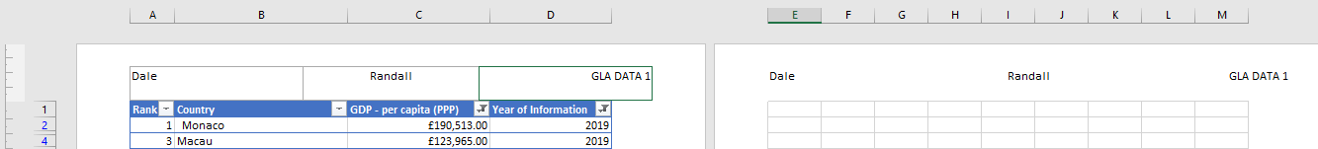Next, I will add **Header** and **Footer**, Click View  
and you will see a box called **Page Layout**Click this and add the relevant informationas per my assignment

To save this data, Click Home at the top left of the screen, Click Save As Named the sheet as Excel Gross domestic procust report 1 and saved file.

**Third Task**

The Wealth of nations’

**Tableau**

https://public.tableau.com/shared/J99GM7RRZ?:display_count=n&:origin=viz_share_link

